Flavour Fusion: AI-Driven Recipe Blogging
Team Leader : C Manasa
Team member : S Md Hassain Ahmed
Team member : Shaik Nadimulla Javeed Basha

1. INTRODUCTION

Project Overview:
Flavour Fusion is an AI-powered web application that automatically generates detailed recipe blogs based on user input. The platform allows users to enter a recipe topic and desired word count, and it generates a complete blog post including ingredients, preparation steps, cooking tips, and a friendly introduction.
The system uses Google Generative AI (Gemini API) for content generation and Streamlit for building the interactive web interface.
This project demonstrates the integration of Generative AI into real-world applications for content automation.

Purpose
The purpose of this project is to:

Automate recipe blog generation using AI.

Reduce manual effort in food content writing.

Provide personalized and creative recipe suggestions.

Demonstrate practical implementation of Generative AI in web applications.
2. IDEATION PHASE

Problem Statement:
Many food bloggers and content creators spend significant time writing recipe blogs manually. Writing engaging, SEO-friendly, and structured recipe articles requires creativity and effort.
There is a need for:
- Automated recipe blog generation
- User-friendly interface
- Fast content creation
- AI-based intelligent text generation

Empathy Map Canvas
User Thinks:
- Writing recipes takes time.
- Needs creative and engaging content.
User Feels:
- Pressured to post regularly.
- Needs inspiration.
User Says:
- “I want quick recipe ideas.”
- “I need blog-ready content.”
User Does:
- Searches for recipe ideas online.
- Manually drafts blog posts.

Brainstorming
Possible solutions discussed:
- AI-based recipe generator
- Template-based blog writing system
- Personalized content recommendation system
- Integration of AI for automatic content generation
- Final solution chosen: AI-driven automated recipe blogging platform.

Objectives:
The main objectives of the project are:
- To develop an AI-based recipe blog generator.
- To integrate Google Gemini API for content creation.
- To design a clean and interactive UI using Streamlit.
- To allow users to specify recipe topic and word count.
- To generate structured blog content automatically.

REQUIREMENT ANALYSIS

Customer Journey Map
- User visits the application.
- User enters ingredients and preferences.
- System processes input using AI model.
- Recipe blog is generated.
- User reads, edits, and downloads content.

Solution Requirement
Functional Requirements:
- User input form for ingredients and preferences.
- AI-based content generation module.
- Blog formatting feature.
- Output display and download option.
Non-Functional Requirements:
- Fast response time.
- User-friendly interface.
- Scalability.
- Data security.

Data Flow Diagram
Level 0 (Context Diagram):
User → Flavour Fusion System → Generated Recipe Blog
Level 1:
User Input → Input Processing → AI Model → Content Formatting → Output

Technology Stack
- Programming Language: Python
- Frontend: HTML/CSS / Streamlit
- Backend: Flask / Django
- AI Integration: Generative AI API
- Database: MySQL / MongoDB
- Deployment: Cloud Hosting Platform

4. PROJECT DESIGN

Problem Solution Fit
The system addresses the need for fast and personalized recipe blog creation by integrating AI-powered content generation, ensuring quality and customization.

Proposed Solution
Flavour Fusion allows users to input ingredients, dietary restrictions, and preferred cuisine. The system generates:
- Recipe Title
- Ingredients List
- Preparation Steps
- Cooking Tips
- Nutritional Insights
- Blog-style Description

System Architecture:
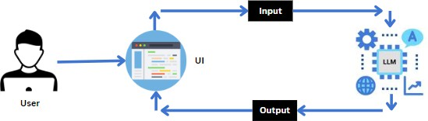

Architecture Flow:
User Input → Streamlit UI → Gemini API → Generated Content → Display to User

Components:
- Frontend – Streamlit
- Backend – Python
- AI Model – Google Gemini 1.5 Flash
- Environment Variables – dotenv

Technologies Used:

Technology Purpose
- Python Core programming
- Streamlit Web interface
- Google GenAI Content generation
- Dotenv API key management

Folder Structure:
Flavour-Fusion/
│
├── app.py
├── .env
├── requirements.txt
├── README.md
└── assets/
└── chatbot_image.png

Methodology:

Step 1: User Input
User enters:
- Recipe Topic
- Word Count

Step 2: Prompt Engineering
A structured prompt is created such as:
“Write a detailed, engaging, SEO-friendly blog post about Malai Kofta including
ingredients, preparation steps, cooking tips, and conclusion.”

Step 3: API Request
The prompt is sent to “Gemini 1.5 Flash Model”.

Step 4: Content Generation
AI generates a complete recipe blog.

Step 5: Output Display
The generated blog is displayed in Streamlit UI.

Implementation:
- Installing Required Libraries: pip install google-generativeai pip install python-dotenv
pip install streamlit

Main Code Structure:
import streamlit as st
import google.generativeai as genai import os

import random
from dotenv import load_dotenv

Load API Key:
load_dotenv()
api_key = os.getenv("GOOGLE_API_KEY") genai.configure(api_key=api_key)
- Model Configuration: generation_config = { "temperature": 0.75,
"top_p": 0.95,
"top_k": 64,
"max_output_tokens": 2048,
}

Creating Model:
model = genai.GenerativeModel( model_name="gemini-1.5-flash-latest", generation_config=generation_config
)

Generate Recipe Function:
def generate_recipe(topic, word_count): prompt = f"""
Write a detailed recipe blog about {topic}.
The blog should be approximately {word_count} words. Include:

- Introduction
- Ingredients
- Step-by-step preparation
- Tips
- Conclusion
"""response = model.generate_content(prompt) return response.text

User Interface Design: Features:
  - Clean heading
  - Chatbot-style introduction
  - Input fields:
    - Recipe topic
    - Word count
  - Generate button
  - Joke section while generating
  - Styled background

Output:
When user enters:
Topic: Malai Kofta ,Word Count: 500 The system generates:
  - Introduction
  - Ingredients list
  - Cooking steps

  - Pro tips
  - Conclusion

PROJECT PLANNING & SCHEDULING
Phase | Activity | Duration
Phase 1 | Requirement Gathering | 1 Week
Phase 2 | System Design | 1 Week
Phase 3 | Development | 2 Weeks
Phase 4 | Testing | 1 Week
Phase 5 | Deployment | 1 Week

FUNCTIONAL AND PERFORMANCE TESTING

Performance Testing
- Tested response time for content generation.
- Verified accuracy of structured output.
- Tested system with multiple input combinations.
- Ensured scalability under multiple users.
Results showed:
- Fast response generation.
- Structured and readable blog outputs.
- Stable performance.

Results

Output Screenshots:

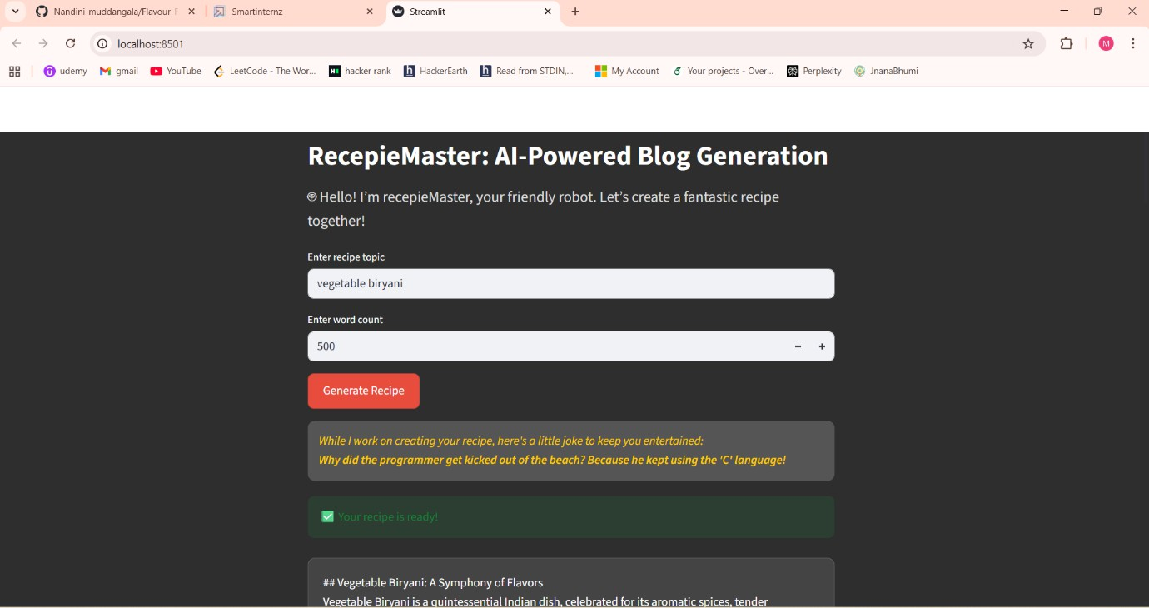

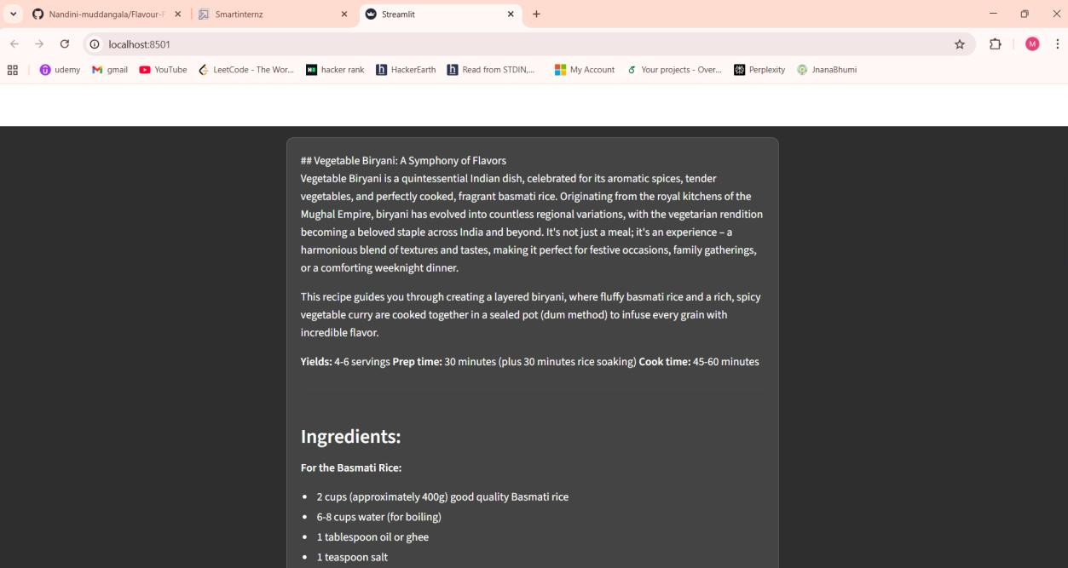

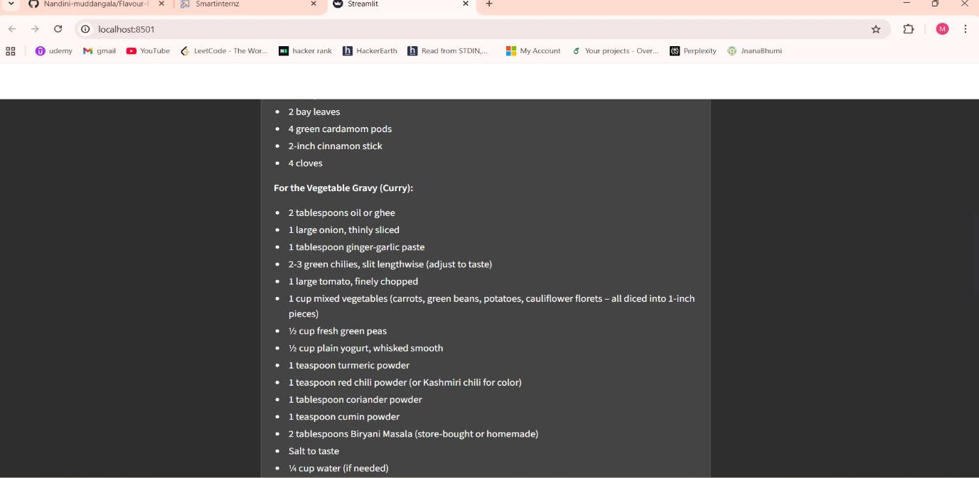
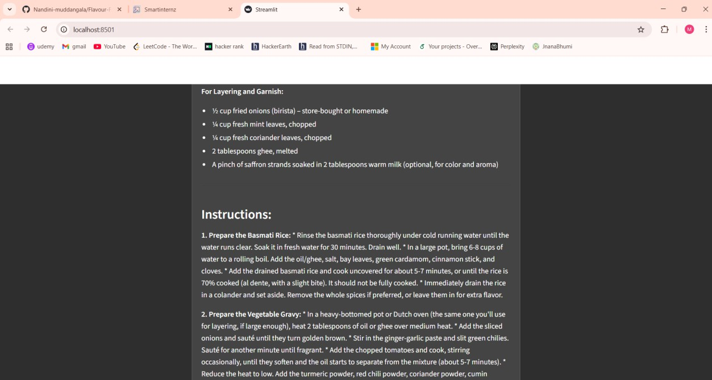
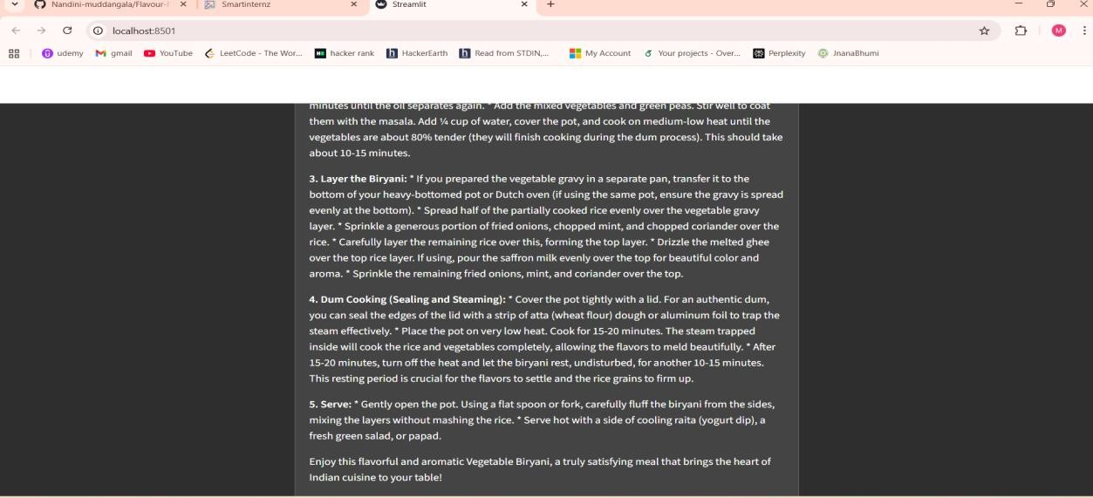

- ADVANTAGES & DISADVANTAGES

Advantages:
- Saves time
- AI-powered automation
- Easy to use
- No writing skills required
- Customizable word count

Disadvantages
- AI output may require minor editing.
- Dependent on internet connectivity.
- Requires prompt optimization for best results.
- Conclusion:
Flavour Fusion is an AI-driven recipe blogging platform that automates the creation of structured and engaging blog posts. By integrating Streamlit with the Gemini 1.5 Flash model, the system efficiently generates customized recipe content based on user input.
The project demonstrates the practical application of Generative AI in content automation, improving productivity while maintaining quality and flexibility. With further enhancements, the platform can evolve into a comprehensive AI- based blogging solution.
10 . FUTURE SCOPE
- Voice-enabled recipe generation.
- Multi-language support.
- AI-generated food images.
- Mobile application version.
- Integration with social media platforms.
- Smart grocery list generator.

- APPENDIX
GitHub Link :
https://github.com/Nandini-muddangala/Flavour-Fusion-AI-Driven-Recipe-Blogging/tree/main
Project Demo Link : https://drive.google.com/file/d/1_yWBRkLHAtOC9m4RRk1Tgs9v3FXWjKs5/view?pli=1

